Introduction to Rocks
TASK 1: The passage of text below is a very good introduction to rocks. However some terrible teacher has mixed up all the sentences in each paragraph and the sentences are in the wrong order. Your task is to identify the topic sentence in each paragraph and write it down in your notebook. Then write out the rest of the sentences in the paragraph in the correct order. There are five paragraphs to complete. The first one is the easiest, and the last one is the hardest.
Paragraph 1
- On this basis, all rocks fall into one of three groups: igneous, metamorphic and sedimentary.
- 1b - Rocks are classified by considering firstly how they were formed.
Paragraph 2
- Volcanic rocks have smaller crystals than plutonic rocks.
- Igneous rocks which form on top of the surface of the earth are called volcanic igneous rocks.
- This is because they cool faster and the crystals have less time to form.
- Rocks which are classified as igneous have been formed as molten (melted) rock cools and solidifies either on top of the earth’s crust or under the surface.
- Those formed under the earth’s surface are called plutonic igneous rocks.
Paragraph 3
- This results in the crystals or particles in the rocks being melted and recrystallised and/or deformed.
- Rocks are changed by intense heat inside the earth, or by the pressures which accompany movements of the earth’s crust.
- Metamorphic rocks are formed when other rocks are changed heat and pressure.
Paragraph 4
- Sediments are particles from other rocks which have been weathered into small pieces.
- Sedimentary rocks are those formed from sediments.
- Here they fall to the bottom.
- These sediments are carried by running water, wind or ice to lakes or the oceans.
Paragraph 5 (NOTE- this para follows on from para 4, probably should not be a separate para by itself)
- At the same time, chemicals dissolved in the water crystallise out in the spaces between the particles of sediment and cement them firmly together.
- These slowly change into solid rock as the weight of the top layers compress the sediments in the bottom layers together.
- As the sediment accumulates, layers form.

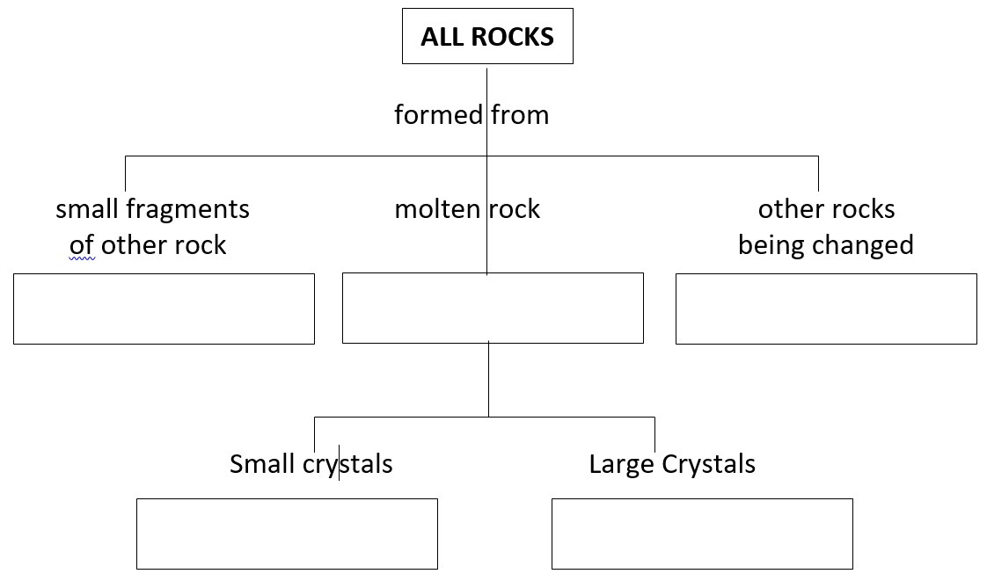
TASK 2: Cut out the flowchart on the right and paste it into your book. The flowchart is a summary of the information above, but the words in the boxes are missing. Use the information in the paragraphs to complete the missing words in the boxes.

